

Lab Experiment – 01

8-Puzzle Problem

Aim
To solve the 8-Puzzle problem using the Breadth-First Search (BFS) algorithm.

Objective
To find the shortest path from the initial state to the goal state by moving the blank tile.

Algorithm
- Start with the initial puzzle state.
- Insert the initial state into a queue.
- Remove the first state from the queue.
- Check whether it is the goal state.
- If it is the goal state, display the solution.
- Otherwise, generate all possible neighboring states.
- Add all unvisited neighboring states to the queue.
- Repeat the process until the goal state is reached or the queue becomes empty

FlowChart:
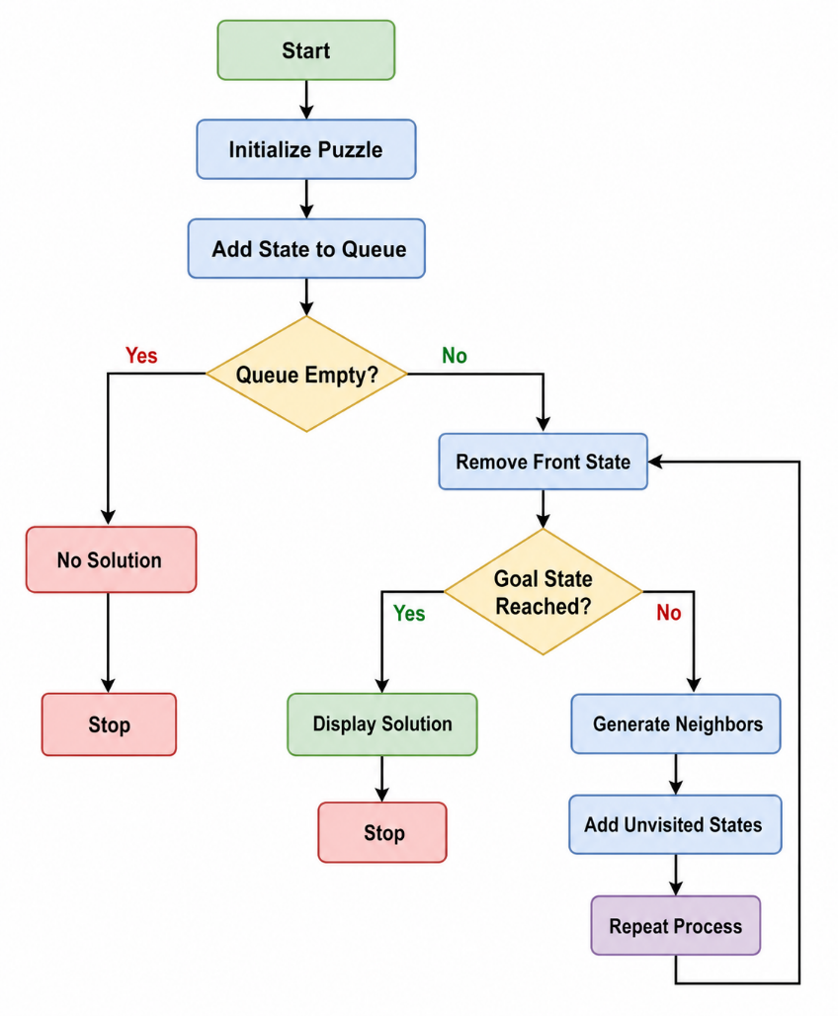
Code:
from collections import deque

goal = [1, 2, 3,
4, 5, 6,
7, 8, 0]

def get_neighbors(state):
neighbors = []
index = state.index(0)

moves = {
0: [1, 3],
1: [0, 2, 4],
2: [1, 5],
3: [0, 4, 6],
4: [1, 3, 5, 7],
5: [2, 4, 8],
6: [3, 7],
7: [4, 6, 8],
8: [5, 7]
}

for move in moves[index]:
new_state = state[:]
new_state[index], new_state[move] = new_state[move], new_state[index]
neighbors.append(new_state)

return neighbors

def solve(start):
queue = deque([(start, [])])
visited = []

while queue:
state, path = queue.popleft()

if state == goal:
return path + [state]

if state in visited:
continue

visited.append(state)

for neighbor in get_neighbors(state):
queue.append((neighbor, path + [state]))

return None

start = [1, 2, 3,
4, 5, 6,
0, 7, 8]

solution = solve(start)

if solution:
print("Solution Steps:")
for step in solution:
print(step[0:3])
print(step[3:6])
print(step[6:9])
print()
else:
print("No Solution Found")

Output:
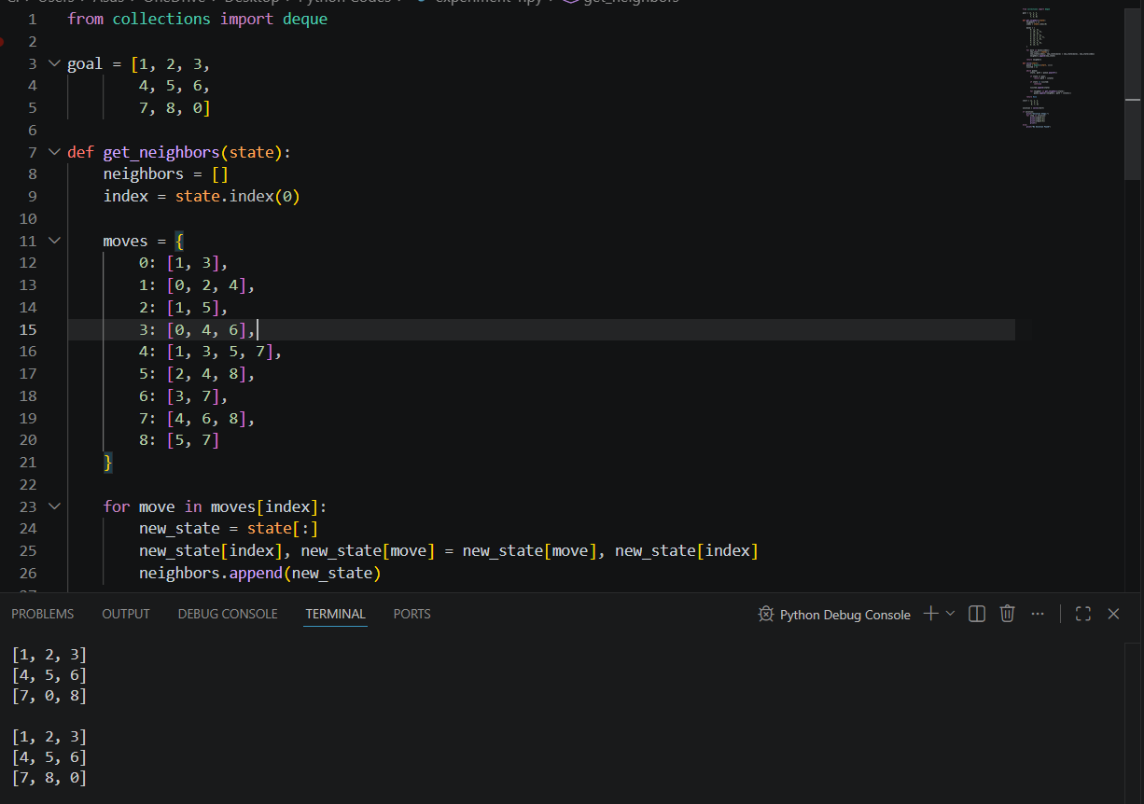

Result
The 8-Puzzle problem is solved successfully using the Breadth-First Search (BFS) algorithm.

Conclusion
The BFS algorithm successfully finds the shortest sequence of moves required to reach the goal state from the initial state.

